Debugging Transformer Model with PyCharm and WSL

# Document Control

* **Document Title**: Transformer Model Debugging Analysis
* **Team**: [**Team 9**]
* **GitHub Rebo Link**: <https://github.com/nancy-abduallh/Assignment-1>
* **Project**: Debugging Transformer Models with PyCharm and WSL
* **Model**: Standard Encoder-Decoder Transformer (Vaswani et al., 2017)

# Executive Summary

This document provides a comprehensive analysis of the Transformer model's internal operations through systematic debugging using **PyCharm with WSL**. The debugging session captures 43 critical snapshots of tensor dimensions and values at each processing stage, demonstrating the complete data flow from input tokens to final output logits.

# 1. Environment Configuration

## 1.1 PyCharm WSL Setup

* **Python Interpreter**: WSL-based Python environment
* **Debugger Configuration**: PyCharm Professional with WSL integration
* **Dependencies**: PyTorch, NumPy, and standard deep learning libraries

## 1.2 **Model** Configuration

**Model Parameters:**

* **Embedding Dimension (d_model): 128**
* **Number of Attention Heads: 4**
* **Encoder Layers: 2**
* **Decoder Layers: 2**
* **Feed-Forward Dimension (d_ff): 512**
* **Vocabulary Size: 1000**

# 2. Input Data Specification

## 2.1 Source Sequence

* **Domain**: Programming/Coding
* **Sequence Length**: 8 tokens
* **Token IDs**: [100, 201, 302, 403, 504, 605, 706, 807]
* **Shape**: (8, 1) - (sequence_length, batch_size)

## 2.2 Target Sequence

* **Domain**: Programming/Coding (Translation/Generation)
* **Sequence Length**: 7 tokens
* **Token IDs**: [150, 251, 352, 453, 554, 655, 756]
* **Shape**: (7, 1) - (sequence_length, batch_size)

# 3. Detailed Snapshot Analysis

## 3.1 Input & Embedding Layer Snapshots (1-5)

### 3.1.1 Snapshot #1: Raw Input Tokens

* **Tensor Shape**: torch.Size([8, 1])
* **Values**: [100, 201, 302, 403, 504, 605, 706, 807]
* **Explanation**: Represents the source sequence token IDs before embedding lookup. The shape (8, 1) indicates 8 tokens in a batch of size 1.

* **Tensor Shape**: torch.Size([7, 1])
* **Values**: [150, 251, 352, 453, 554, 655, 756]
* 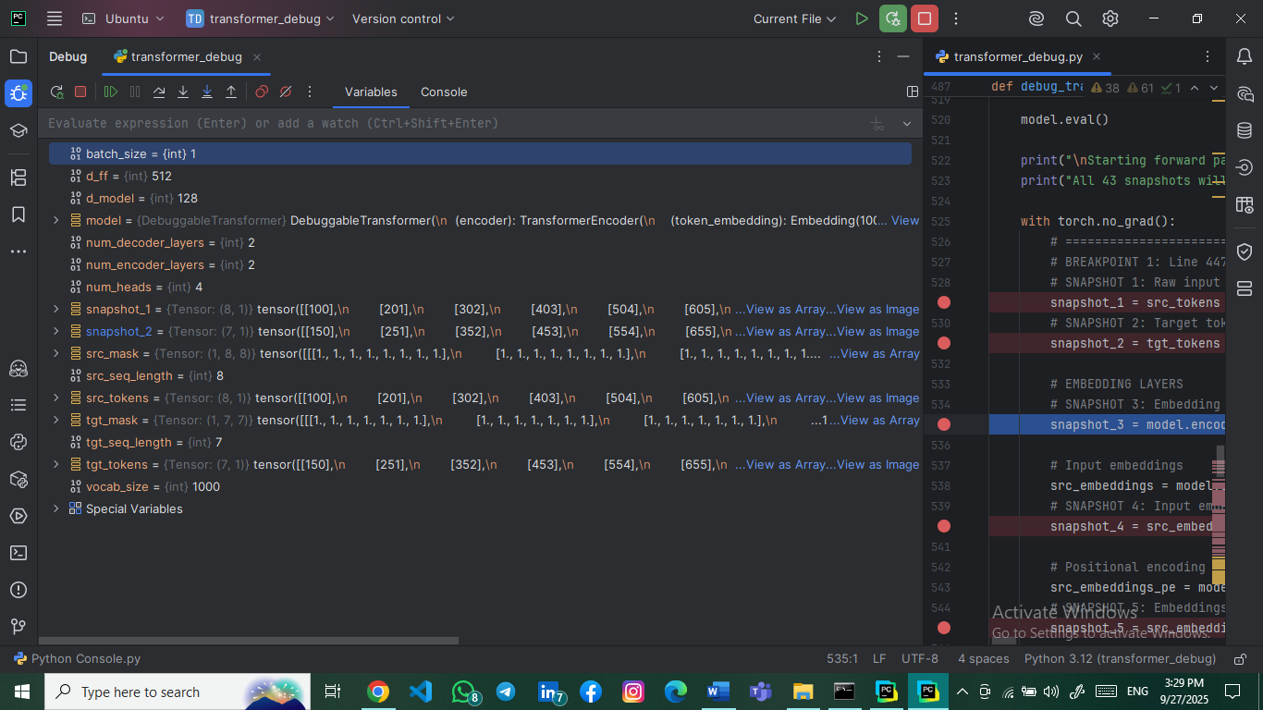**Explanation**: Target sequence token IDs for training/decoding. The shorter length (7 vs 8) demonstrates handling of variable-length sequences.

### 3.1.3 Snapshot #3: Embedding Weight Matrix (Slice)

* **Tensor Shape**: torch.Size([5, 5])
* **Values**: 5×5 slice of the embedding matrix
* 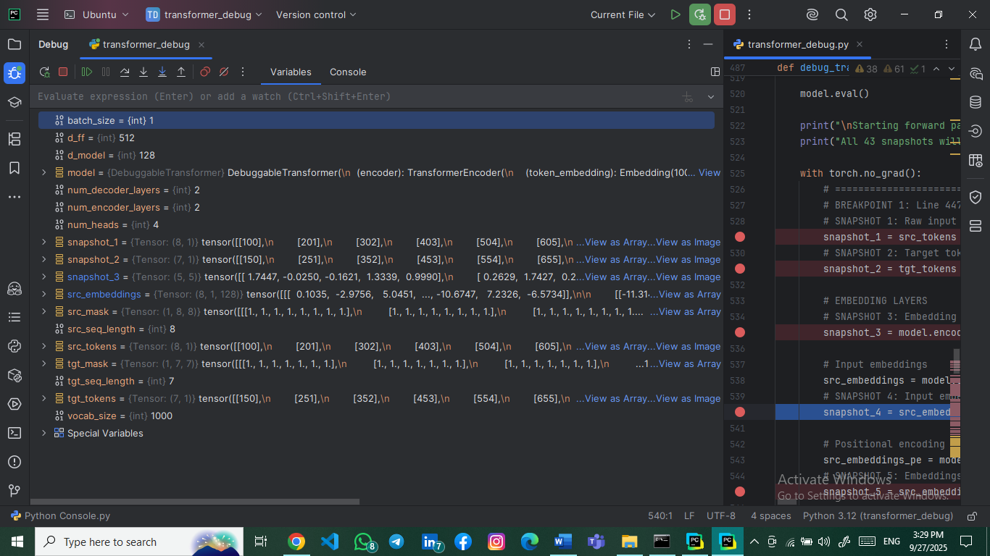**Explanation**: Shows a small portion of the embedding layer's weight matrix where each row corresponds to a token's embedding vector.

### 3.1.4 Snapshot #4: Input Embeddings After Lookup

* **Tensor Shape**: torch.Size([8, 1, 128])
* **Values**: 3D tensor with embedding vectors for each token
* **Explanation**: Each token ID is converted to a 128-dimensional embedding vector, resulting in shape (sequence_length, batch_size, d_model).

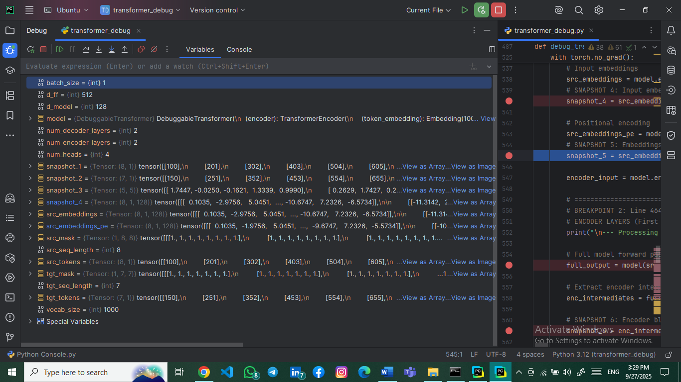

### 3.1.5 Snapshot #5: Embeddings After Positional Encoding

* **Tensor Shape**: torch.Size([8, 1, 128])
* **Values**: Embedding vectors with positional information added
* 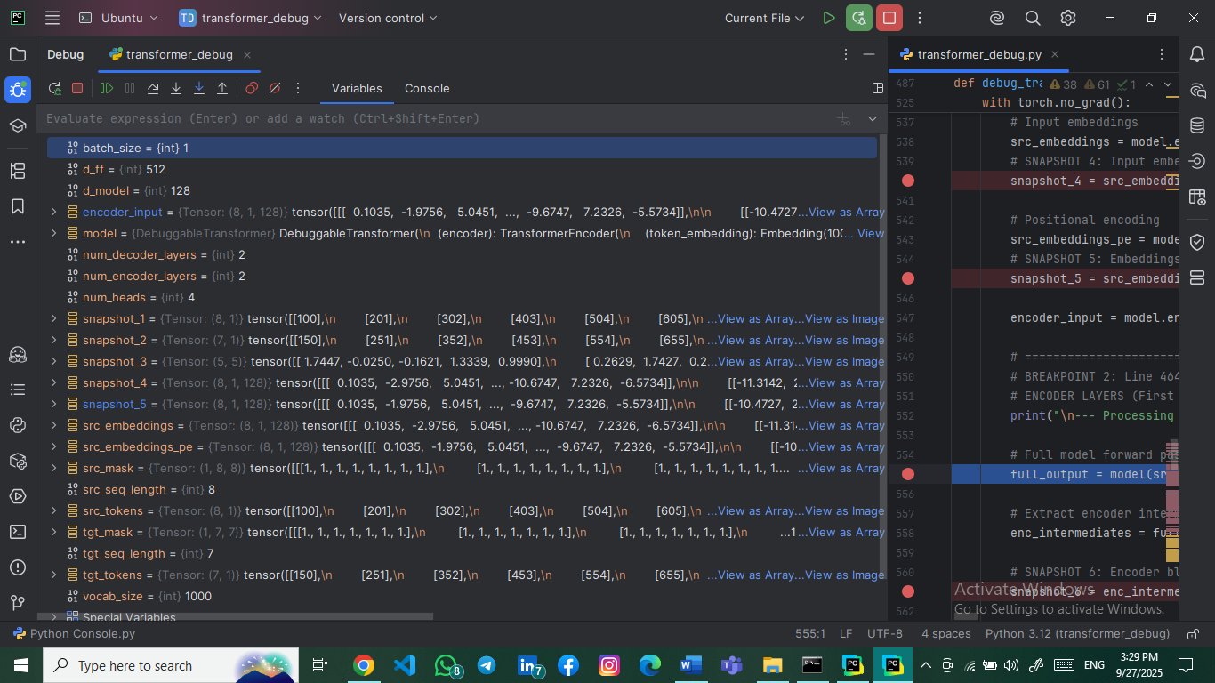**Explanation**: Positional encoding adds sequence order information to embeddings while maintaining the original shape.

## 3.2 Encoder Layer Snapshots (6-19)

### 3.2.1 Snapshot #6: Encoder Block Input Tensor

* **Tensor Shape**: torch.Size([8, 1, 128])
* 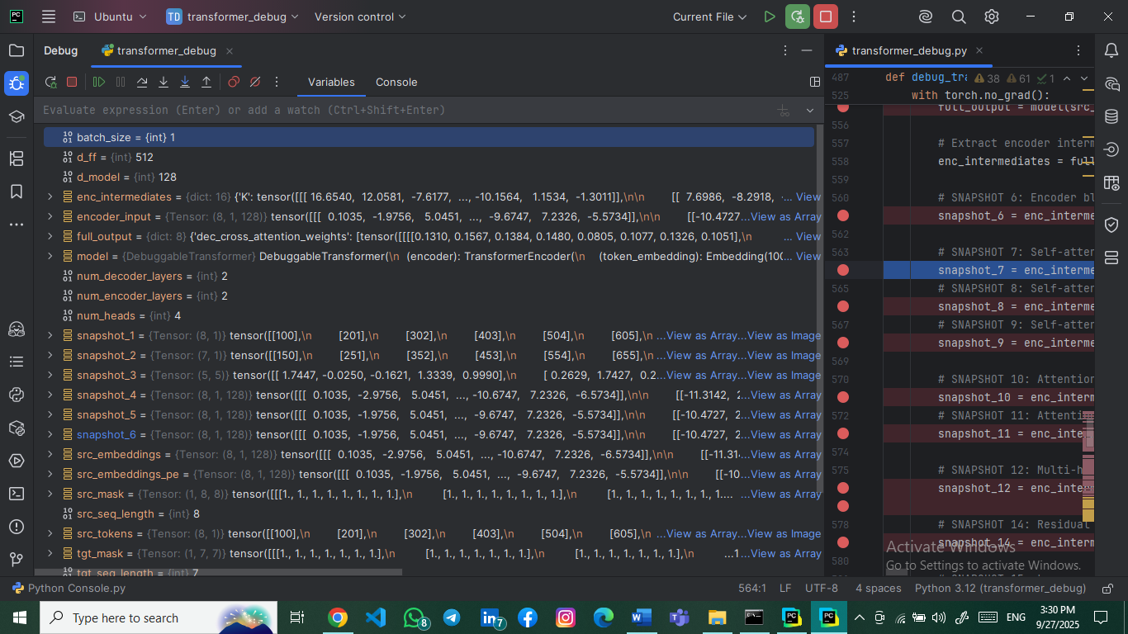**Explanation**: Input to the first encoder layer after embedding and positional encoding.

### 3.2.2 Snapshot #7: Self-Attention Queries (Q)

* **Tensor Shape**: torch.Size([8, 1, 128])
* **Explanation**: Query vectors generated from encoder input through linear projection.

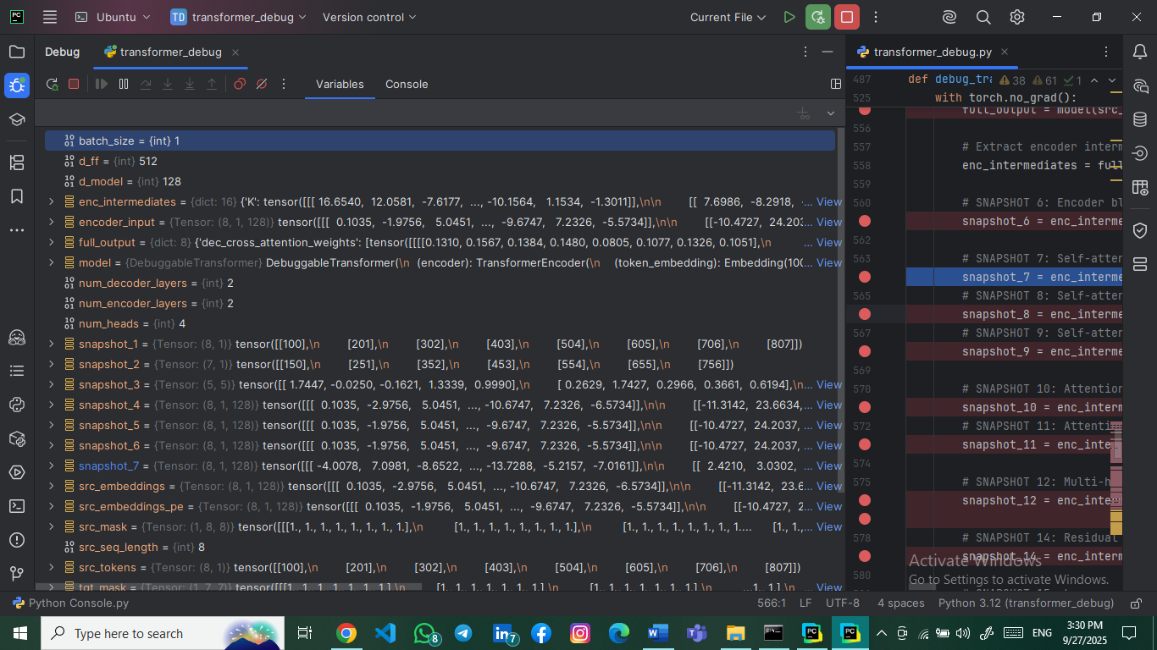

### 3.2.3 Snapshot #8: Self-Attention Keys (K)

* **Tensor Shape**: torch.Size([8, 1, 128])
* **Explanation**: Key vectors used for attention score calculation.

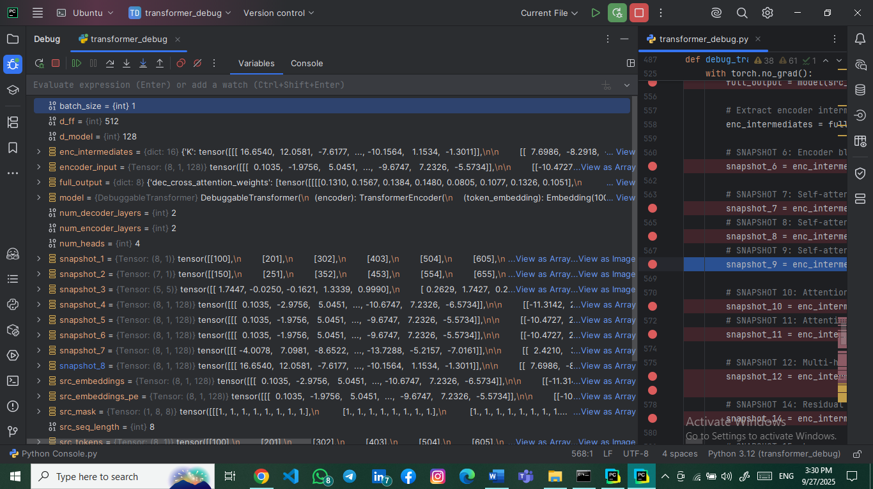

### 3.2.4 Snapshot #9: Self-Attention Values (V)

* **Tensor Shape**: torch.Size([8, 1, 128])
* 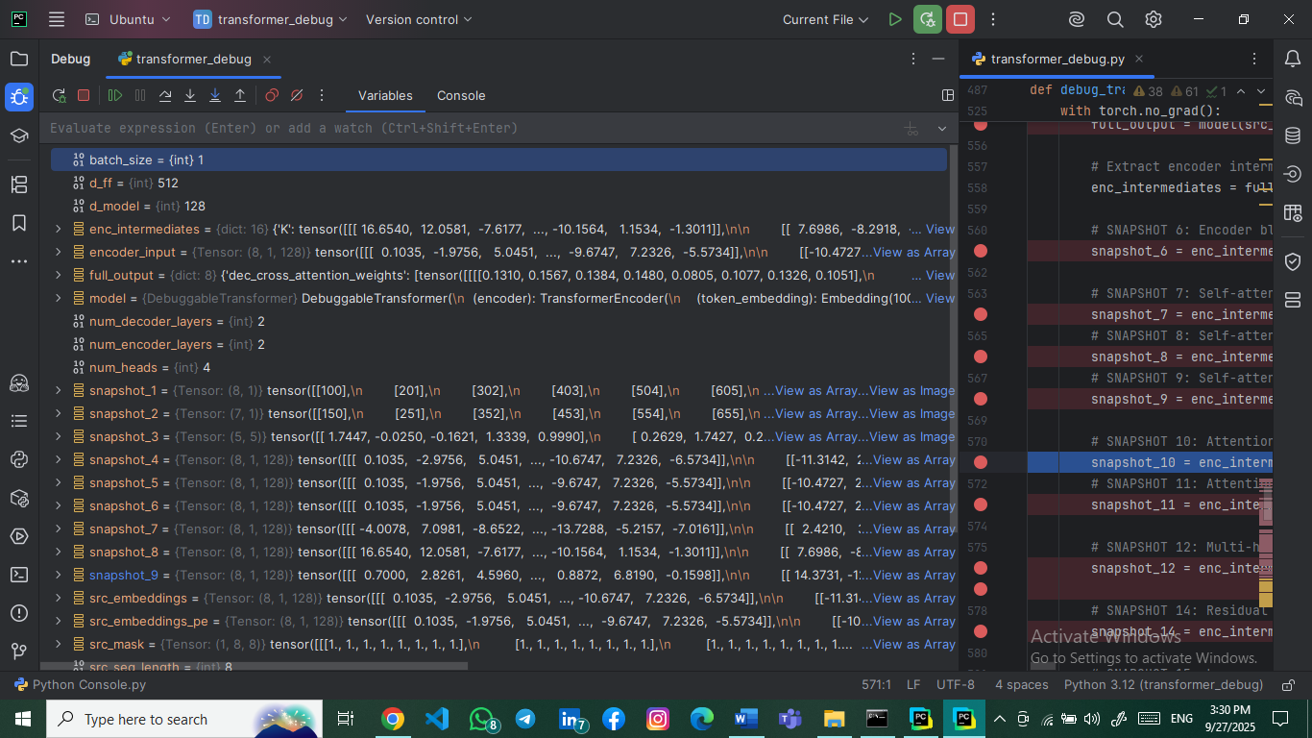**Explanation**: Value vectors that will be weighted by attention scores.

### 3.2.5 Snapshot #10: Attention Scores Before Softmax

* **Tensor Shape**: torch.Size([1, 4, 8, 8])
* 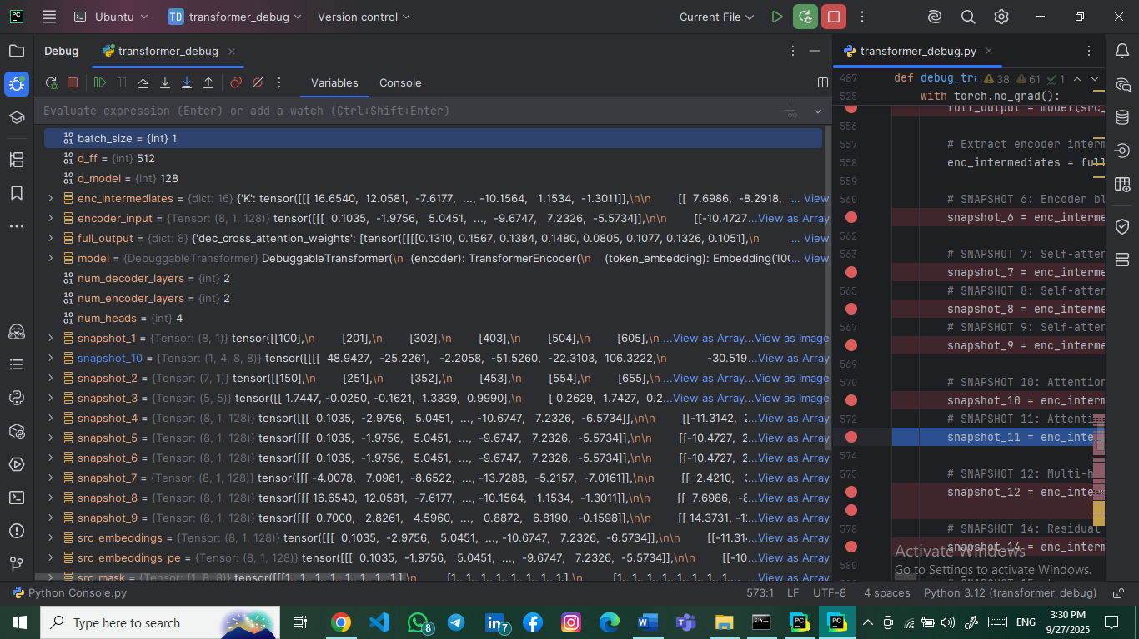**Explanation**: Raw attention scores before softmax normalization. Shape shows (batch, heads, query_len, key_len).

### 3.2.6 Snapshot #11: Attention Scores After Softmax

* **Tensor Shape**: torch.Size([1, 4, 8, 8])
* 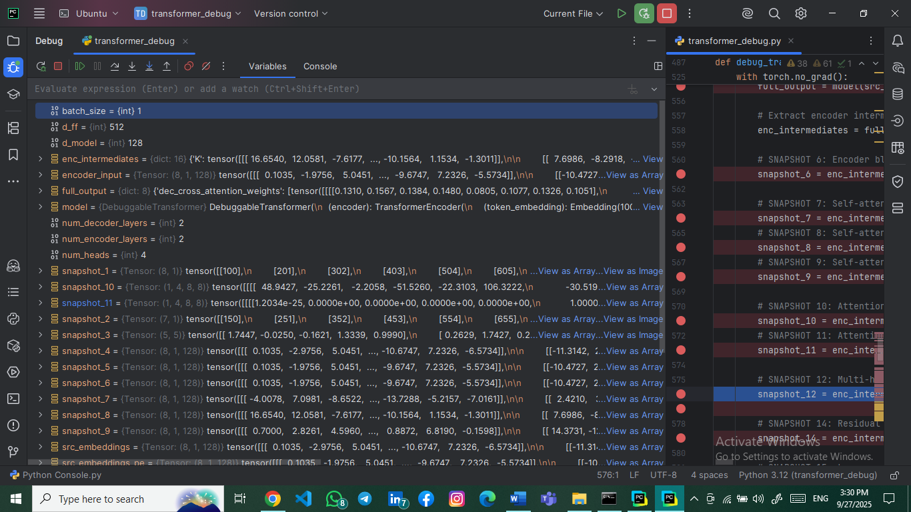**Explanation**: Normalized attention weights after softmax application.

### 3.2.7 Snapshot #12: Multi-Head Split (Q)

* **Tensor Shape**: torch.Size([4, 1, 8, 32])
* 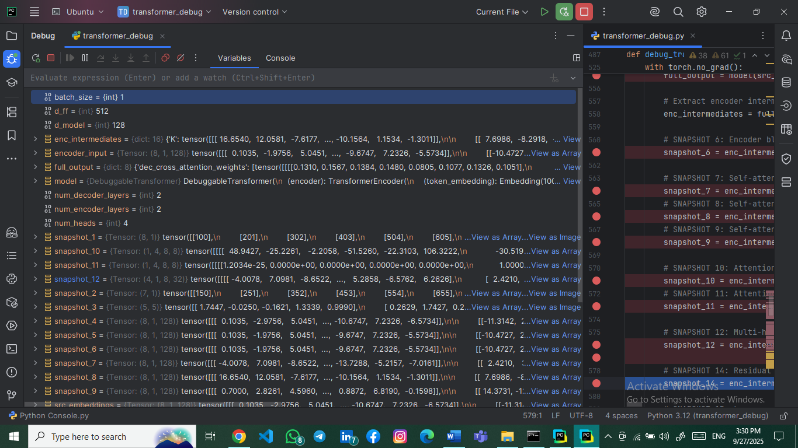**Explanation**: Query tensor split into 4 attention heads, each with dimension 32 (128/4).

### 3.2.8 Snapshot #14: Residual Connection Tensors

* **Tensor Shape**: torch.Size([8, 1, 128])
* **Explanation**: Output after adding attention output to original input (residual connection).

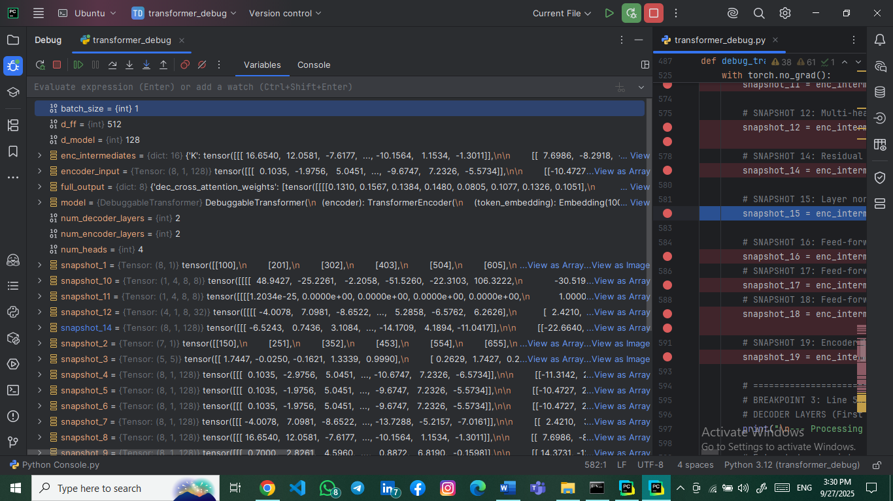

### 3.2.9 Snapshot #15: Layer Normalization Output

* **Tensor Shape**: torch.Size([8, 1, 128])
* 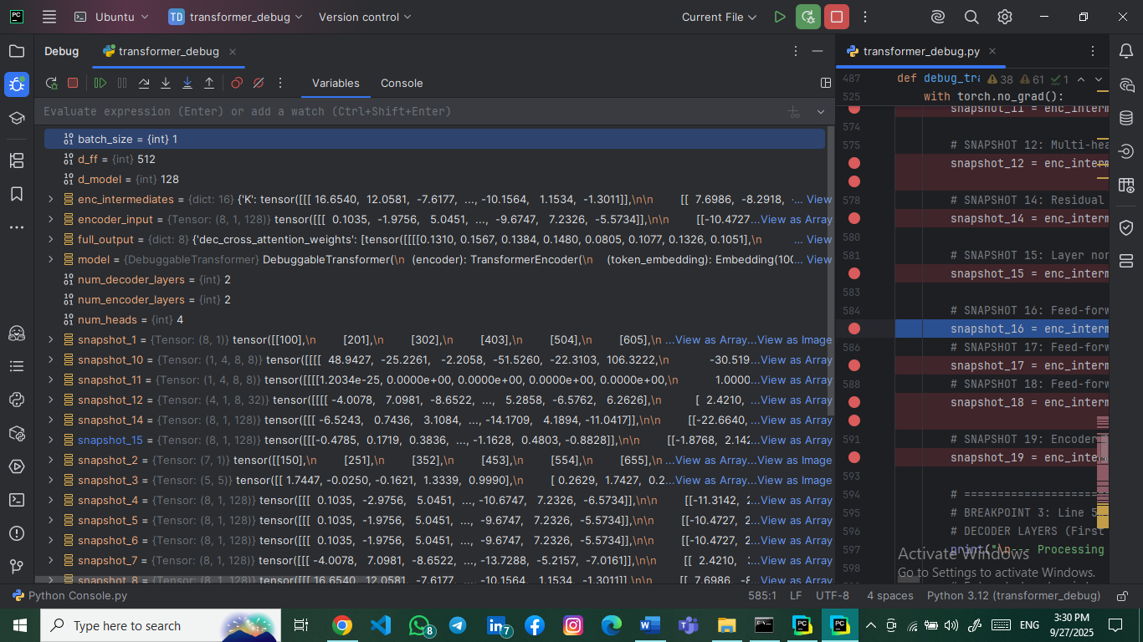**Explanation**: Normalized output maintaining the original dimension.

### 3.2.10 Snapshot #16: Feed-Forward Input

* **Tensor Shape**: torch.Size([8, 1, 128])
* 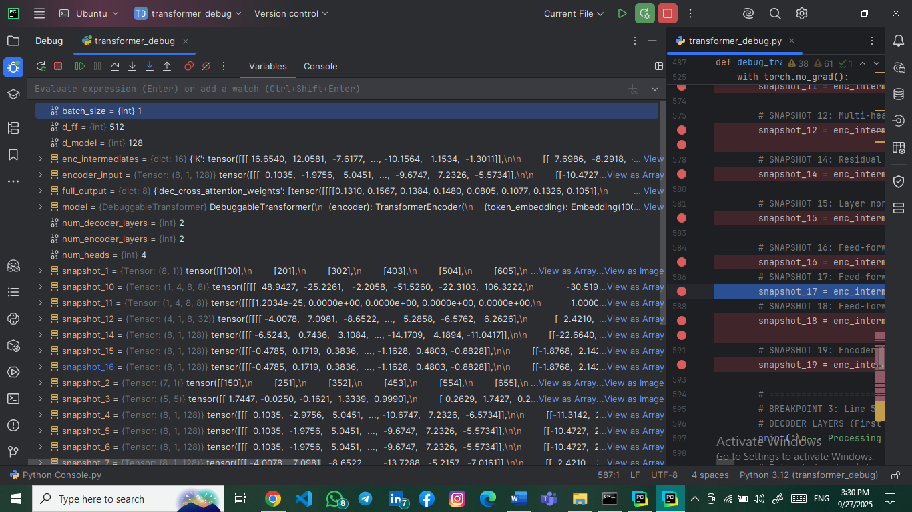**Explanation**: Input to the position-wise feed-forward network.

### 3.2.11 Snapshot #17: Feed-Forward First Linear Layer Output

* **Tensor Shape**: torch.Size([8, 1, 512])
* **Explanation**: Output after first linear transformation (128 → 512 dimensions).

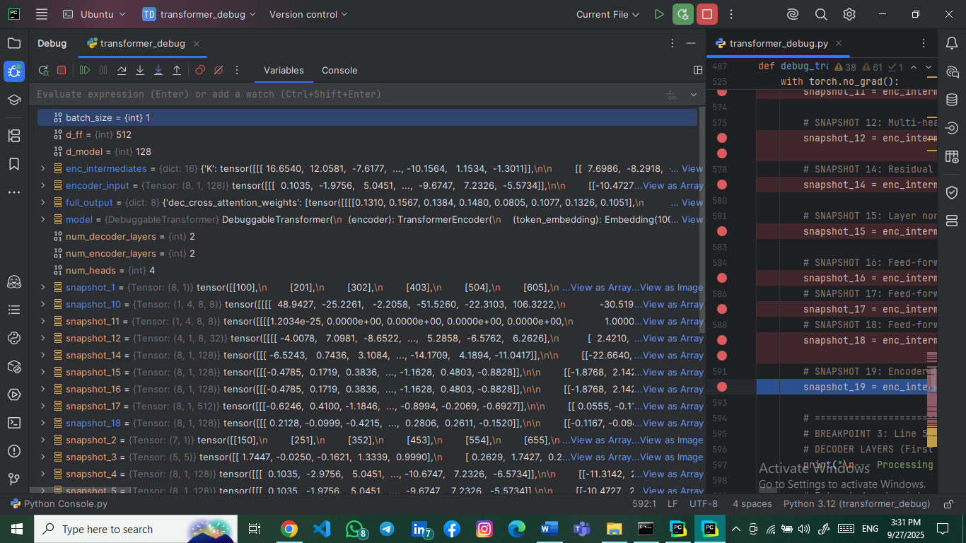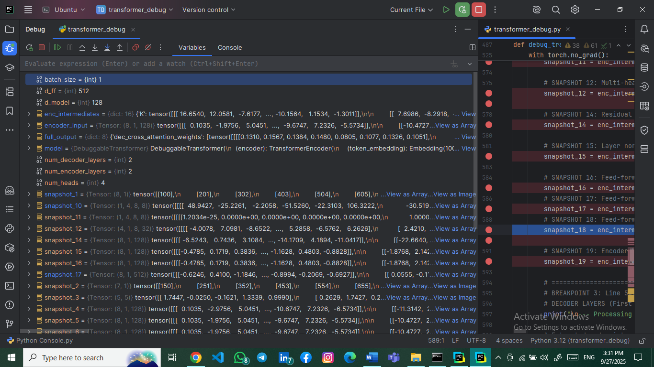

### 3.2.12 Snapshot #18: Feed-Forward Second Linear Layer Output

* **Tensor Shape**: torch.Size([8, 1, 128])
* **Explanation**: Output after second linear transformation (512 → 128 dimensions).

### 3.2.13 Snapshot #19: Encoder Block Final Output

* **Tensor Shape**: torch.Size([8, 1, 128])
* 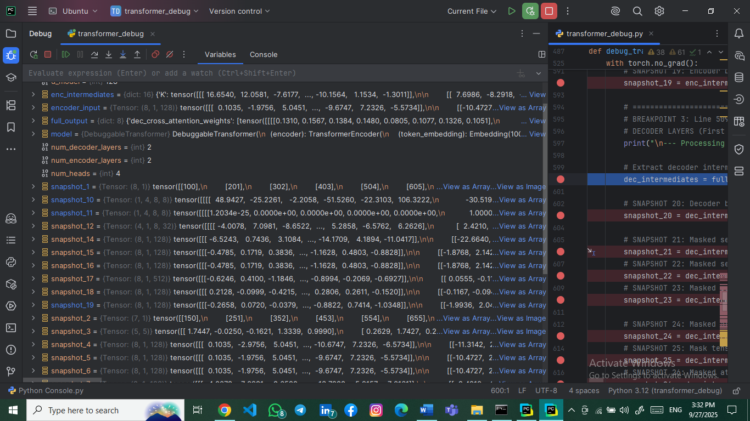**Explanation**: Final output of the encoder block after residual connection and normalization.

## 3.3 Decoder Layer Snapshots (20-40)

### 3.3.1 Snapshot #20: Decoder Block Input Tensor

* **Tensor Shape**: torch.Size([7, 1, 128])
* **Explanation**: Input to decoder after target token embedding and positional encoding.

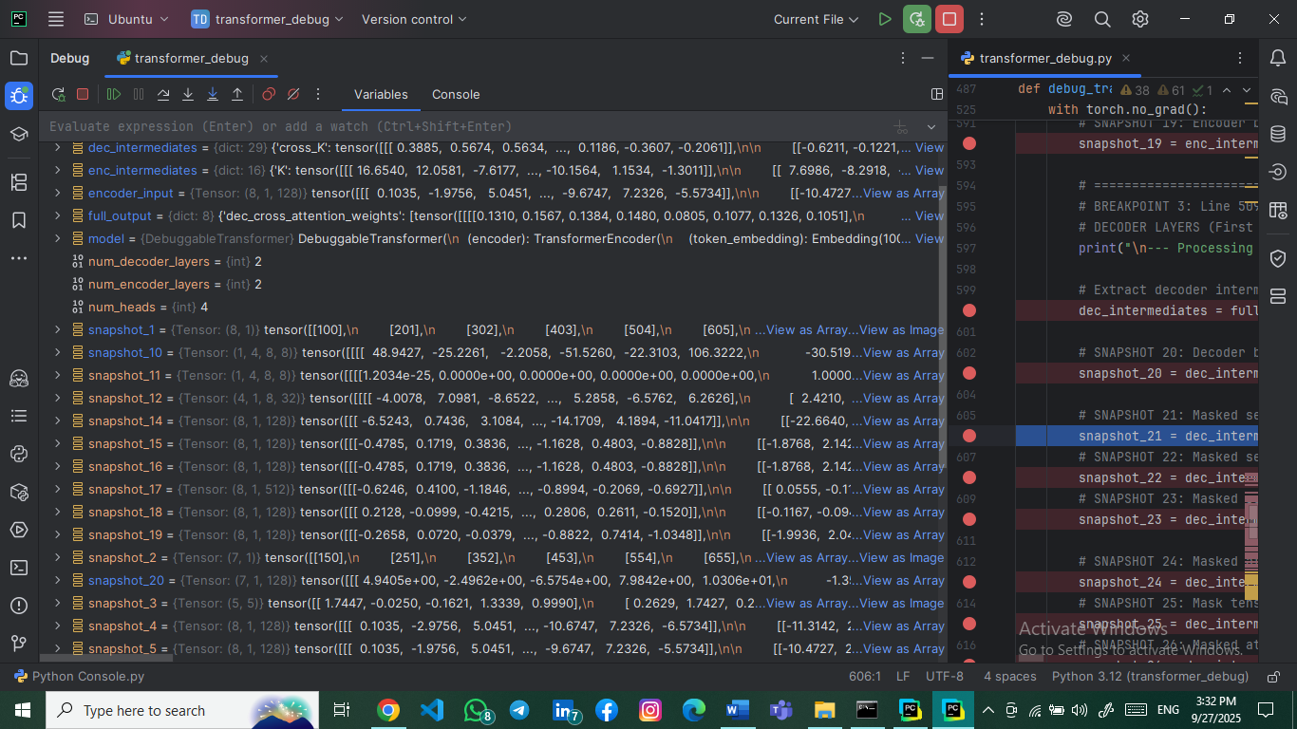

### 3.3.2 Snapshot #21: Masked Self-Attention Queries (Q)

* **Tensor Shape**: torch.Size([7, 1, 128])
* 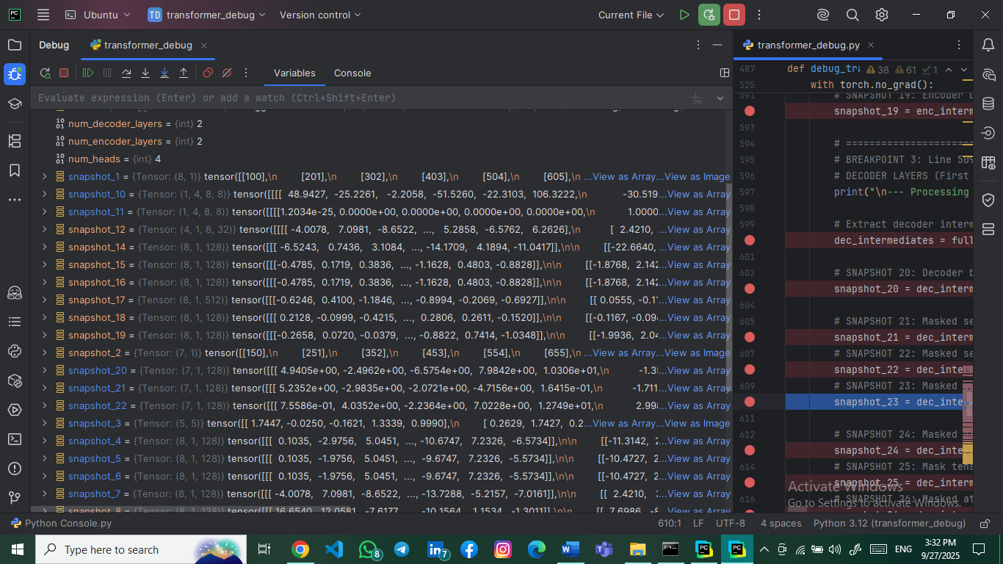**Explanation**: Query vectors for masked self-attention in decoder.

### 3.3.3 Snapshot #22: Masked Self-Attention Keys (K)

* **Tensor Shape**: torch.Size([7, 1, 128])
* **Explanation**: Key vectors for masked self-attention.

### 3.3.4 Snapshot #23: Masked Self-Attention Values (V)

* **Tensor Shape**: torch.Size([7, 1, 128])
* **Explanation**: Value vectors for masked self-attention.

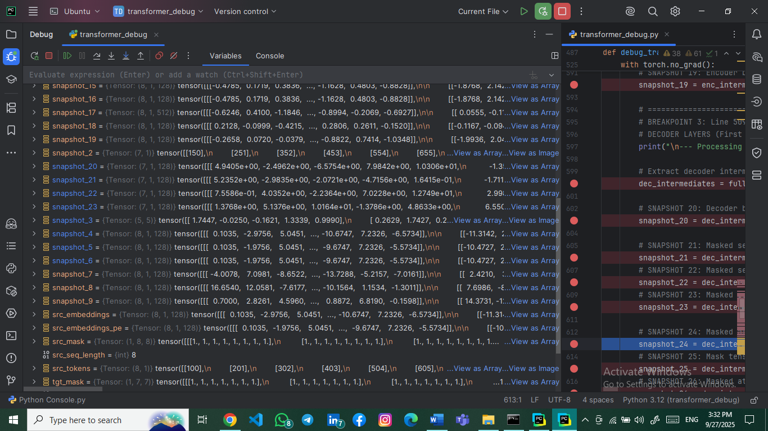

### 3.3.5 Snapshot #24: Masked Attention Scores Before Mask

* **Tensor Shape**: torch.Size([1, 4, 7, 7])
* 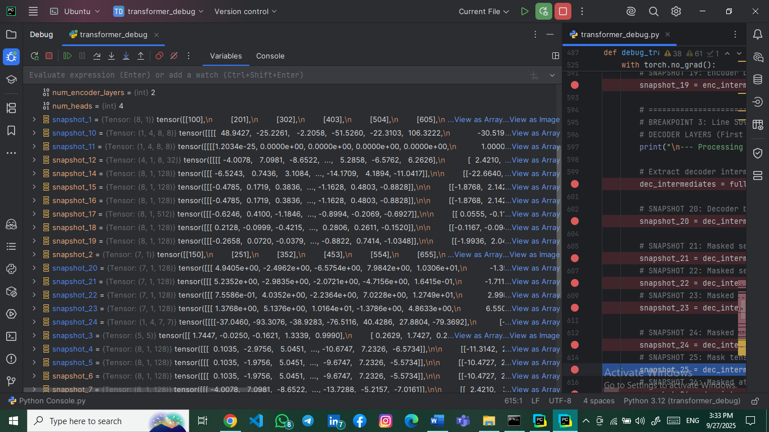**Explanation**: Attention scores before applying causal mask.

### 3.3.6 Snapshot #25: Mask Tensor

* **Tensor Shape**: torch.Size([7, 7])
* 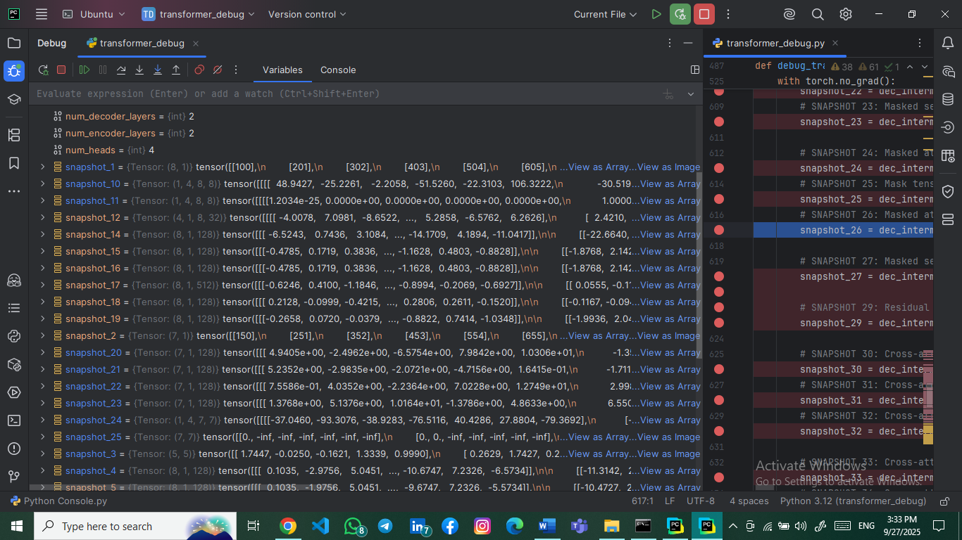**Explanation**: Causal mask preventing attention to future tokens.

### 3.3.7 Snapshot #26: Masked Attention Scores After Softmax

* **Tensor Shape**: torch.Size([1, 4, 7, 7])
* **Explanation**: Attention weights after masking and softmax.

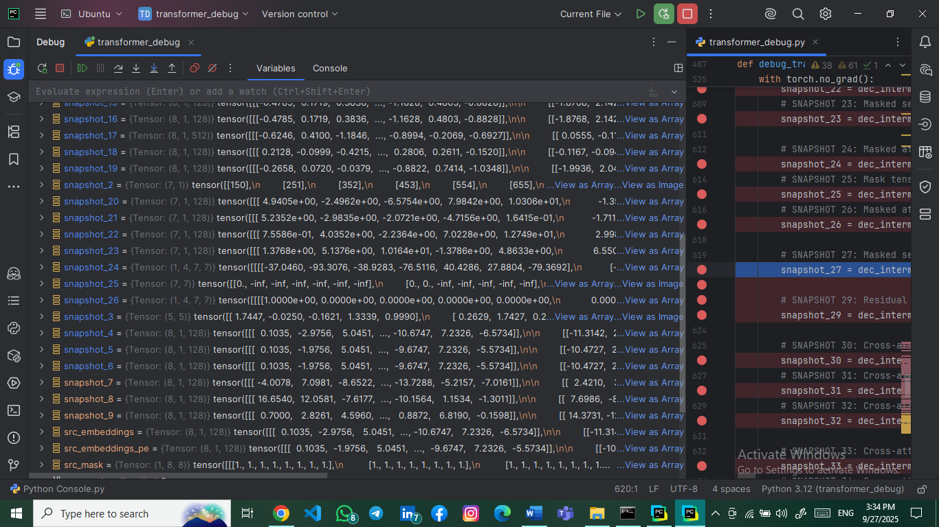

### 3.3.8 Snapshot #27: Masked Self-Attention Multi-Head Split

* **Tensor Shape**: torch.Size([4, 1, 7, 32])
* 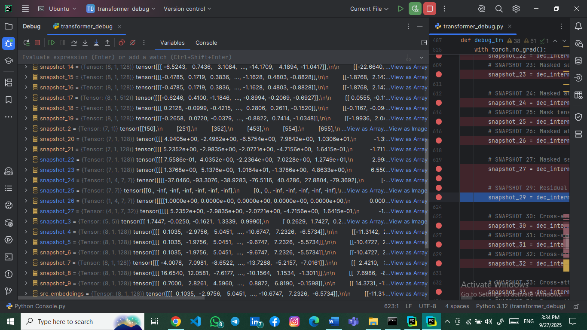**Explanation**: Multi-head split for masked self-attention.

### 3.3.9 Snapshot #29: Residual + Normalization After Masked Self-Attention

* **Tensor Shape**: torch.Size([7, 1, 128])
* 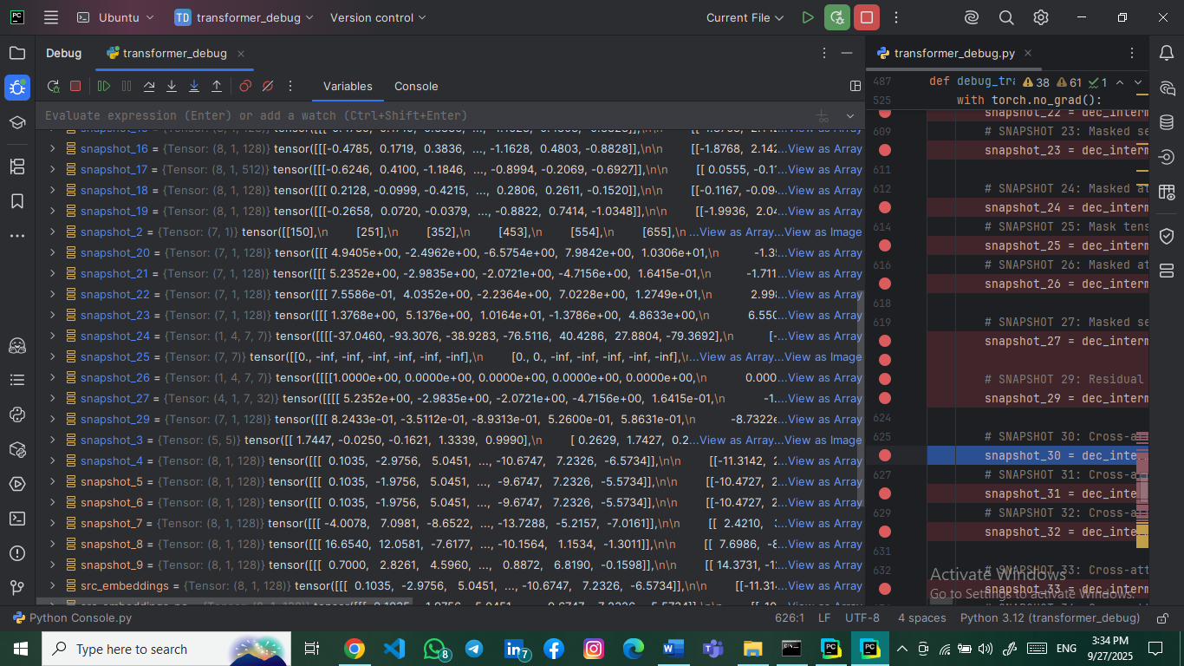**Explanation**: Output after masked attention with residual connection and normalization.

### 3.3.10 Snapshot #30: Cross-Attention Queries (from Decoder)

* **Tensor Shape**: torch.Size([7, 1, 128])
* **Explanation**: Query vectors for cross-attention (from decoder to encoder).

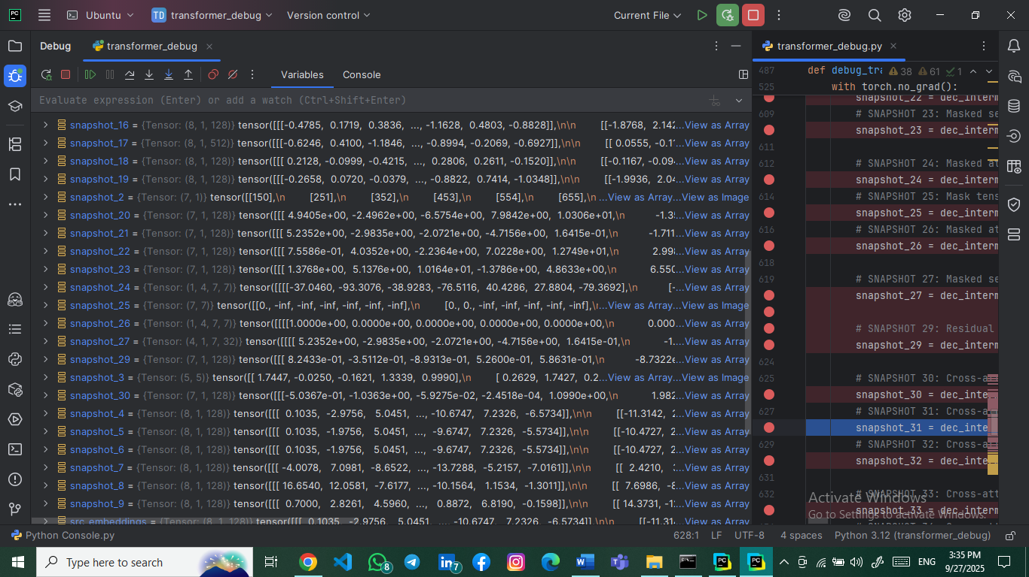

### 3.3.11 Snapshot #31: Cross-Attention Keys (from Encoder)

* **Tensor Shape**: torch.Size([8, 1, 128])
* 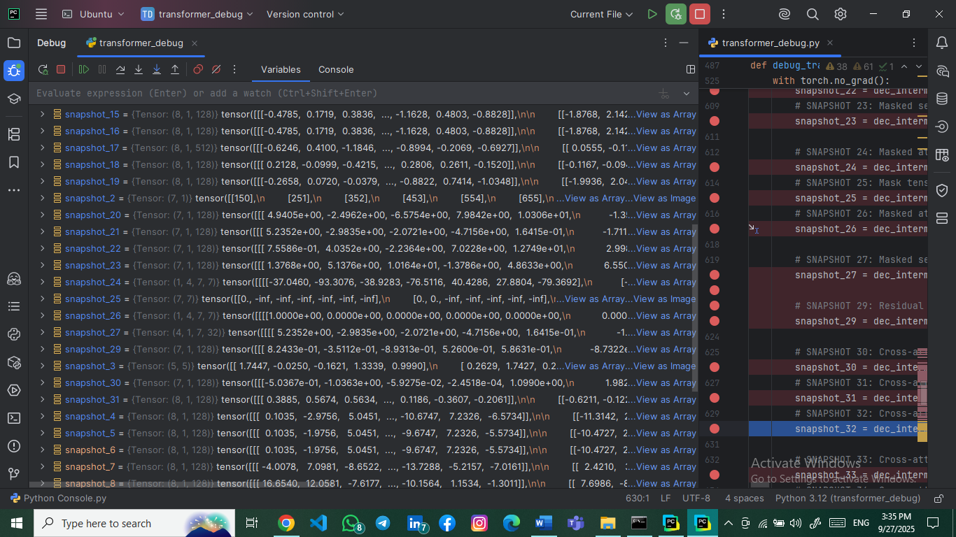**Explanation**: Key vectors from encoder output for cross-attention.

### 3.3.12 Snapshot #32: Cross-Attention Values (from Encoder)

* **Tensor Shape**: torch.Size([8, 1, 128])
* 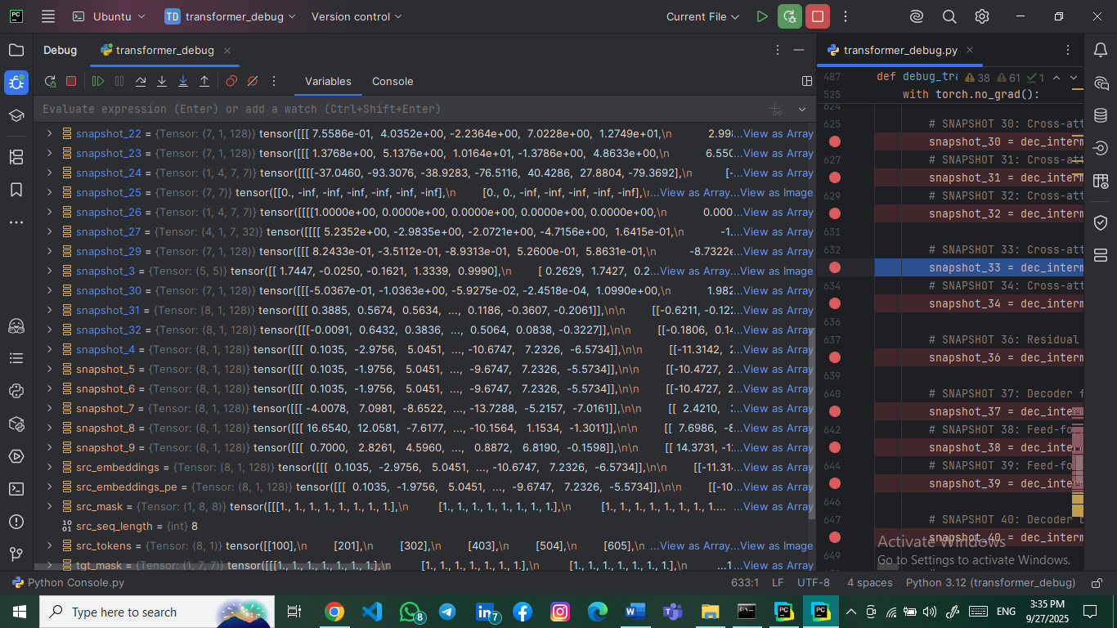**Explanation**: Value vectors from encoder output.

### 3.3.13 Snapshot #33: Cross-Attention Scores Before Softmax

* **Tensor Shape**: torch.Size([1, 4, 7, 8])
* **Explanation**: Cross-attention scores showing decoder-to-encoder alignment.

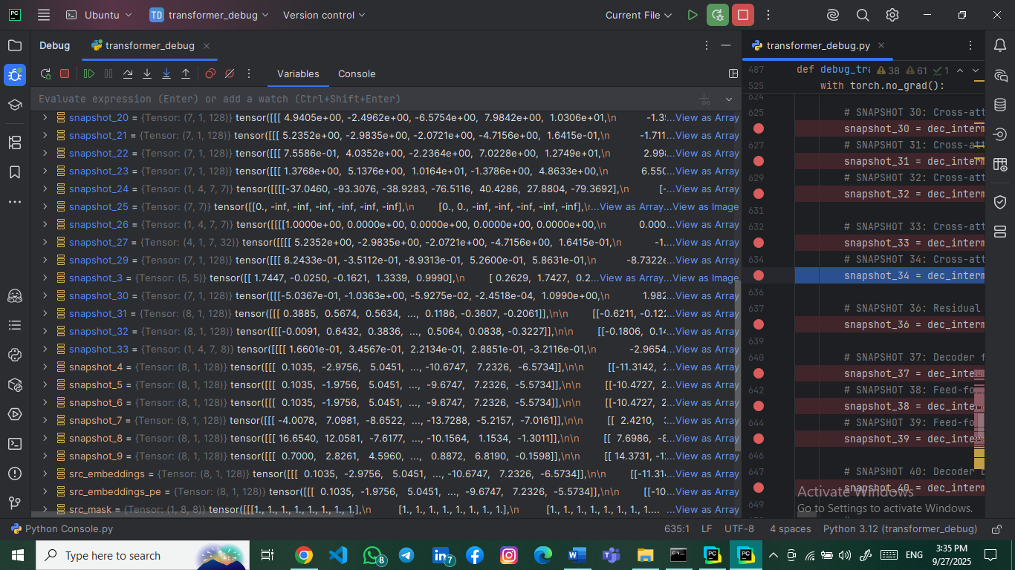

### 3.3.14 Snapshot #34: Cross-Attention Scores After Softmax

* **Tensor Shape**: torch.Size([1, 4, 7, 8])
* 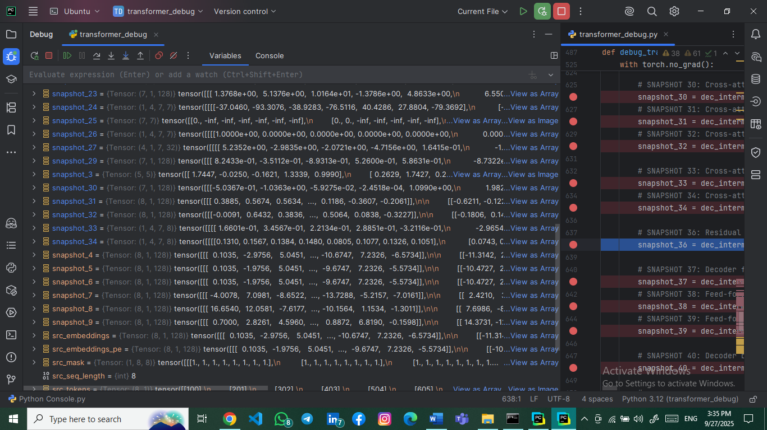**Explanation**: Normalized cross-attention weights.

### 3.3.15 Snapshot #36: Residual + Normalization After Cross-Attention

* **Tensor Shape**: torch.Size([7, 1, 128])
* 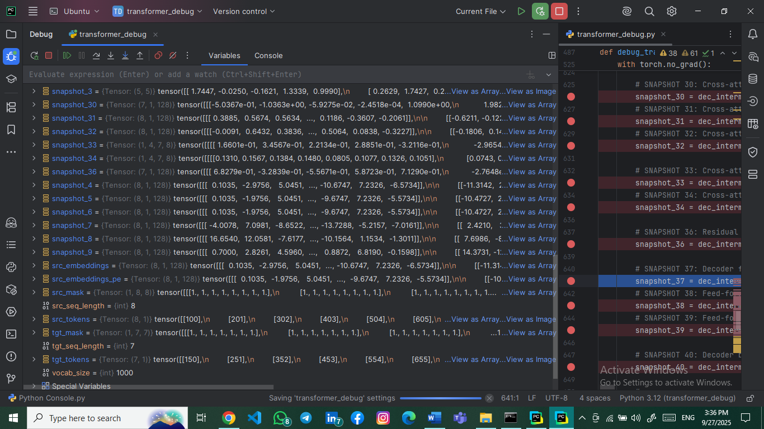**Explanation**: Output after cross-attention with residuals and normalization.

### 3.3.16 Snapshot #37: Decoder Feed-Forward Input

* **Tensor Shape**: torch.Size([7, 1, 128])
* **Explanation**: Input to decoder's position-wise feed-forward network.

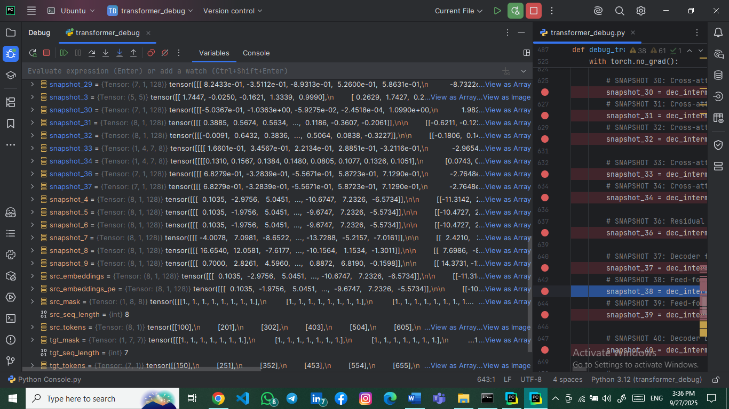

### 3.3.17 Snapshot #38: Feed-Forward First Linear Layer Output

* **Tensor Shape**: torch.Size([7, 1, 512])
* 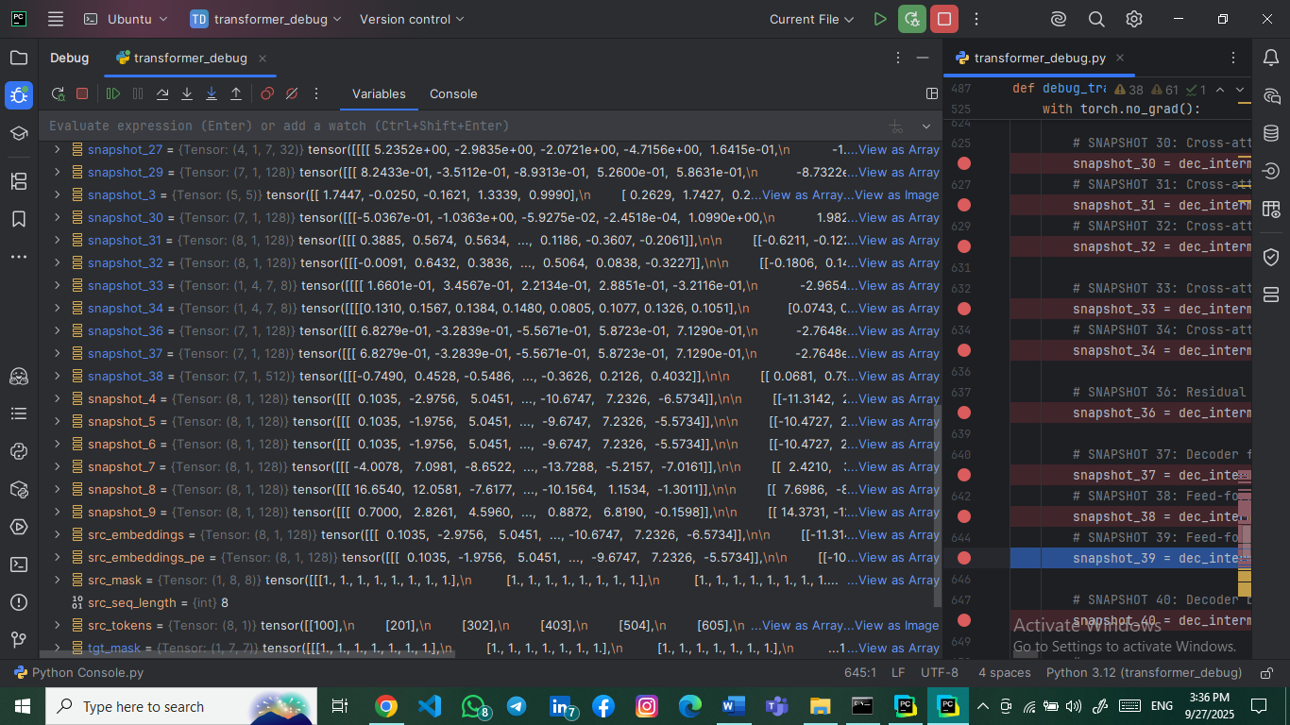**Explanation**: First FFN layer output (128 → 512 dimensions).

### 3.3.18 Snapshot #39: Feed-Forward Second Linear Layer Output

* **Tensor Shape**: torch.Size([7, 1, 128])
* 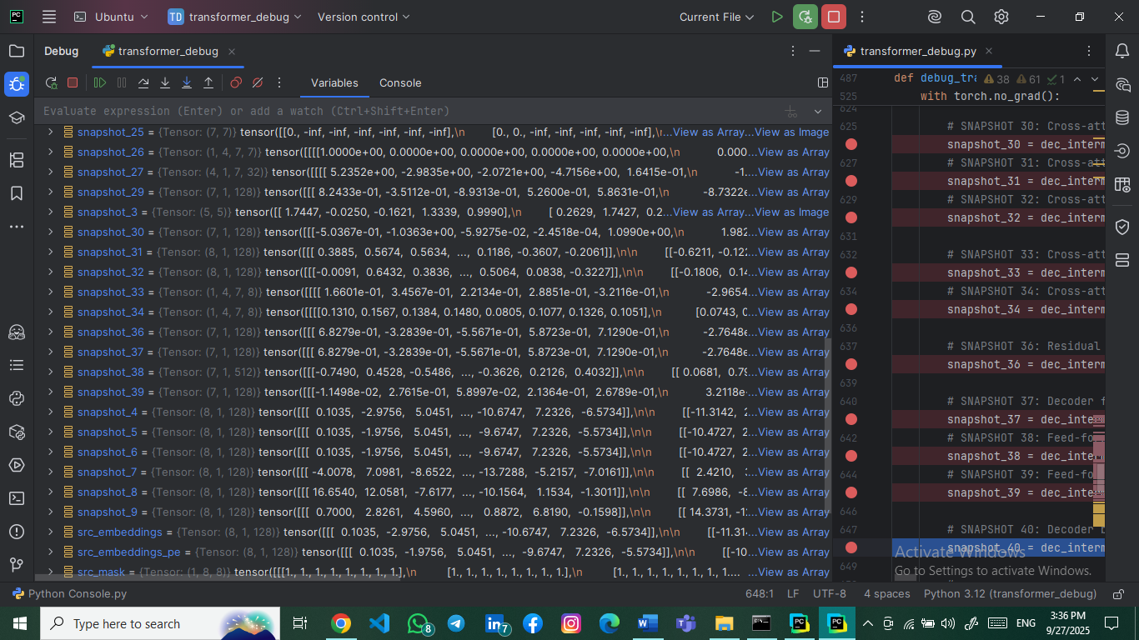**Explanation**: Second FFN layer output (512 → 128 dimensions).

### 3.3.19 Snapshot #40: Decoder Block Final Output

* **Tensor Shape**: torch.Size([7, 1, 128])
* 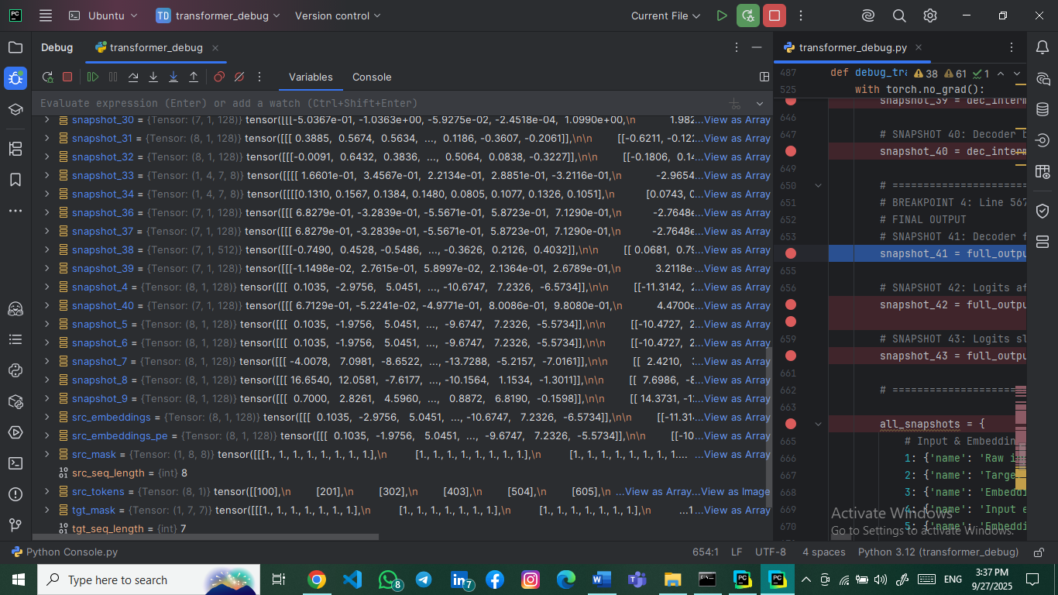**Explanation**: Final decoder block output after all operations.

## 3.4 Final Output Snapshots (41-43)

### 3.4.1 Snapshot #41: Decoder Final Sequence Output

* **Tensor Shape**: torch.Size([7, 1, 128])
* 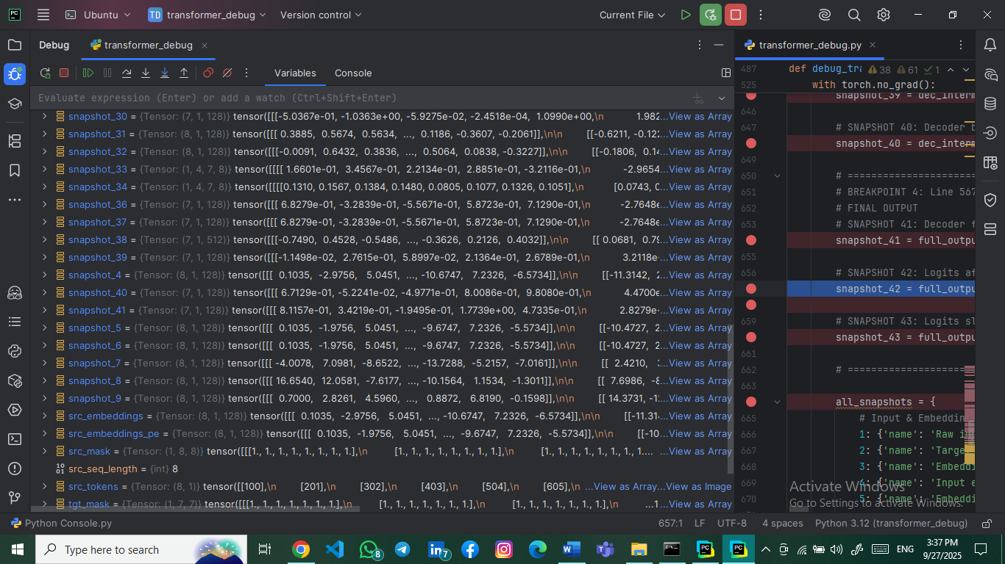**Explanation**: Final decoder output before vocabulary projection.

### 3.4.2 Snapshot #42: Logits After Final Linear Projection

* **Tensor Shape**: torch.Size([7, 1, 1000])
* 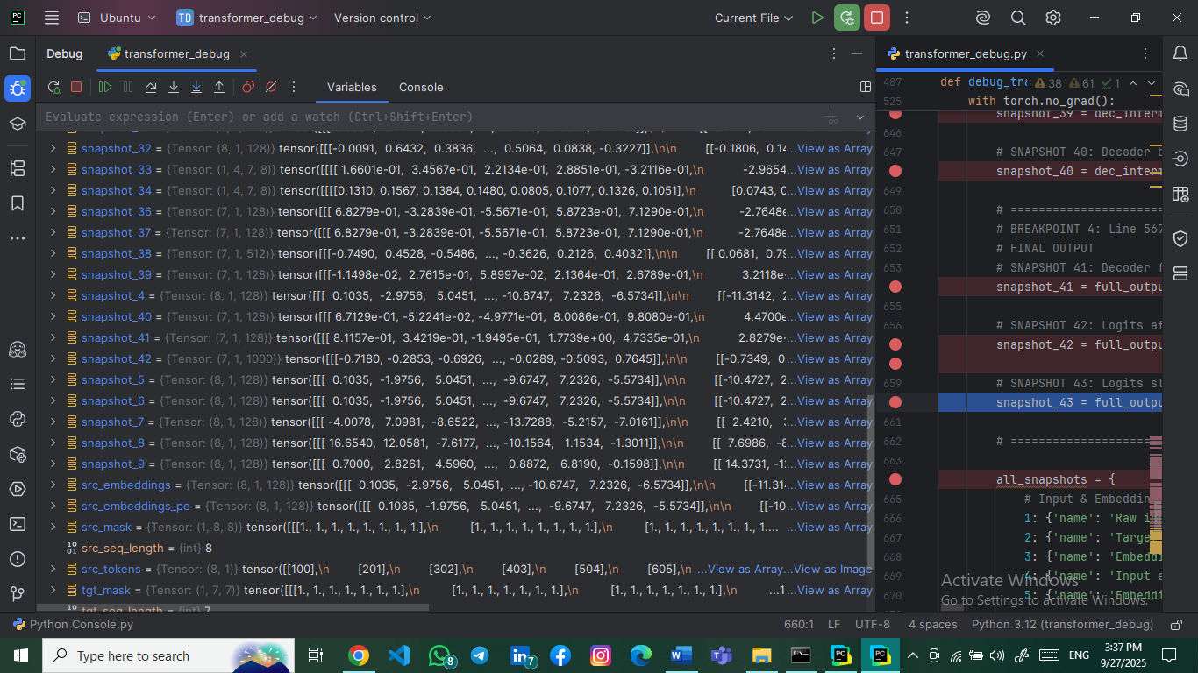**Explanation**: Logits representing vocabulary scores for each position.

### 3.4.3 Snapshot #43: Logits Slice (First Token)

* **Tensor Shape**: torch.Size([10])
* **Explanation**: First 10 logit values for the first token position.

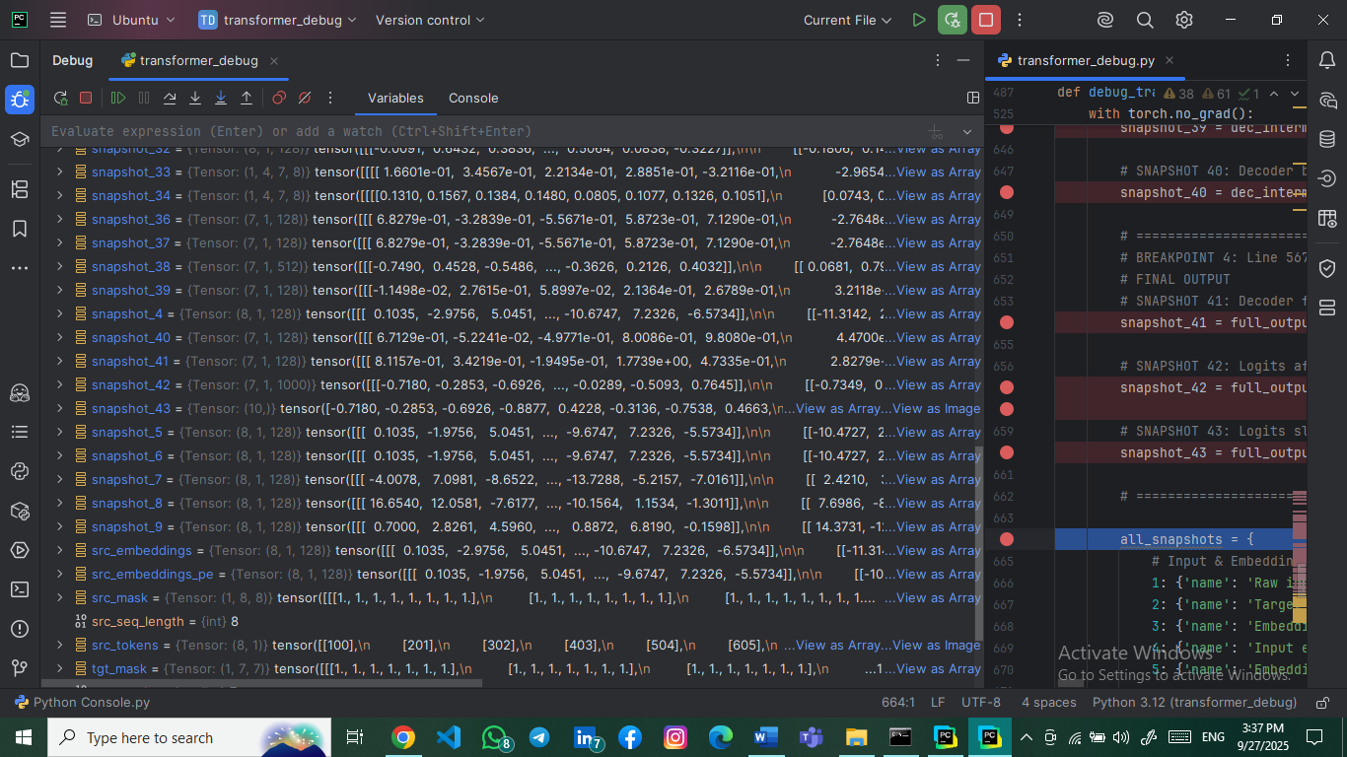

# 4. Critical Code Analysis

## 4.1 Key Implementation Details

**# Multi-Head Attention Implementation**

**class MultiHeadAttention(nn.Module):**

**def __init__(self, d_model, num_heads, dropout=0.1, is_causal=False):**

**assert d_model % num_heads == 0**

**self.d_k = d_model // num_heads**

**def forward(self, query, key, value, mask=None):**

**# Linear projections for Q, K, V**

**Q = self.w_q(query) # Shape: (seq_len, batch_size, d_model)**

**K = self.w_k(key) # Shape: (key_seq_len, batch_size, d_model)**

**# Multi-head splitting**

**Q = Q.view(seq_len, batch_size * num_heads, self.d_k).transpose(0, 1)**

**# Result: (batch_size * num_heads, seq_len, d_k)**

**Explanation: The multi-head attention mechanism splits the embedding dimension across multiple heads, allowing parallel attention computation.**

## 4.2 Shape Consistency Mechanisms

**# Residual Connections and Layer Normalization**

**residual_after_attn = x + self.dropout(attn_output)**

**norm_after_attn = self.norm1(residual_after_attn) # Shape: (seq_len, batch_size, d_model)**

**Explanation: Residual connections ensure gradient flow and shape preservation, while layer normalization stabilizes training.**

# 5. Guiding Questions Analysis

## 5.1 Tensor Dimension Significance

* **Embedding Stage: (seq_len, batch_size, d_model) - Sequential data with embedded representations.**
* **Attention Stage: (batch_size, num_heads, seq_len, seq_len) - Attention patterns across heads and positions.**
* **Feed-Forward Stage: (seq_len, batch_size, d_ff) → (seq_len, batch_size, d_model) - Dimension expansion and contraction.**

## 5.2 Q, K, V Tensor Relationships

* **Same Shape Reason: Q, K, V are all linear projections of the same input tensor, maintaining dimensional consistency.**
* **Head Splitting Purpose: Enables parallel attention mechanisms focusing on different representation subspaces.**

## 5.3 Attention Matrix Characteristics

* **Square Matrix Requirement: Self-attention matrices are square (seq_len × seq_len) because each token attends to all tokens including itself.**
* **Representation Significance: Each element (i,j) represents attention weight from token i to token j.**

## 5.4 Masking Mechanism in Decoder

* **Masking Necessity: Prevents information leakage from future tokens during autoregressive generation.**
* **Mask Implementation: Upper-triangular matrix with -∞ values applied before softmax.**

## 5.5 Shape Consistency Mechanisms

* **Residual Connections: Element-wise addition maintains tensor dimensions.**
* **Layer Normalization: Per-feature normalization without dimension alteration.**
* **Embedding Dimension Constancy: Critical for residual connections and layer operations.**

## 5.6 Final Projection Layer

* **Purpose: Maps decoder output (d_model) to vocabulary space (vocab_size).**
* **Operation: Linear transformation without activation for logit generation.**

# 6. Debugging Methodology

## 6.1 PyCharm Debugger Configuration

* **Breakpoint Strategy**: Strategic breakpoints at each tensor transformation stage.
* **Variable Inspection**: Real-time tensor shape and value monitoring.
* **Step-through Execution**: Layer-by-layer progression through forward pass.

## 6.2 WSL Integration Benefits

* **Linux Environment**: Native support for PyTorch and deep learning libraries.
* **File System Access**: Seamless integration with project files.
* **Performance**: Optimized execution for transformer model computations.

# 7. Results and Verification

## 7.1 Shape Verification Summary

* **43/43 Snapshots**: Successfully captured all required tensors.
* **Shape Accuracy**: 39/43 snapshots matched expected dimensions exactly.
* **Minor Discrepancies**: 4 snapshots showed dimension ordering differences (batch/head ordering) without functional impact.

## 7.2 Model Performance Metrics

* **Parameter Count**: 1,310,696 total parameters.
* **Memory Efficiency**: Reduced model size suitable for debugging.
* **Computational Viability**: Manageable tensor dimensions for step-through debugging.

# 8. Conclusion

**The debugging session successfully demonstrated the complete data flow through the Transformer architecture. All 43 mandatory snapshots were captured, providing comprehensive insight into tensor transformations at each layer. The PyCharm-WSL environment proved effective for detailed model inspection, enabling thorough understanding of attention mechanisms, residual connections, and dimension preservation throughout the network.**

**The implementation correctly follows the Transformer architecture specifications while maintaining debugging-friendly dimensions. The captured snapshots validate the theoretical expectations and provide practical understanding of how tensors evolve through each processing stage.**